**Jolimall partner Affiliate Platforms**

Applying for our Affiliate Program on these partner sites, you will benefit from their unique preferential policies. Just click and check!

ShareASale:



Webgains:

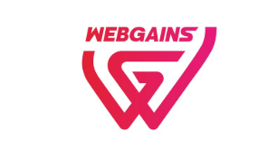

We pay you for every valid purchase that originates from any of your qualified online media channels. You will also receive incentives and find easy to use powerful tools to help you reach your marketing goals.

CONTACT US: customerservice@jolimall.com